2.

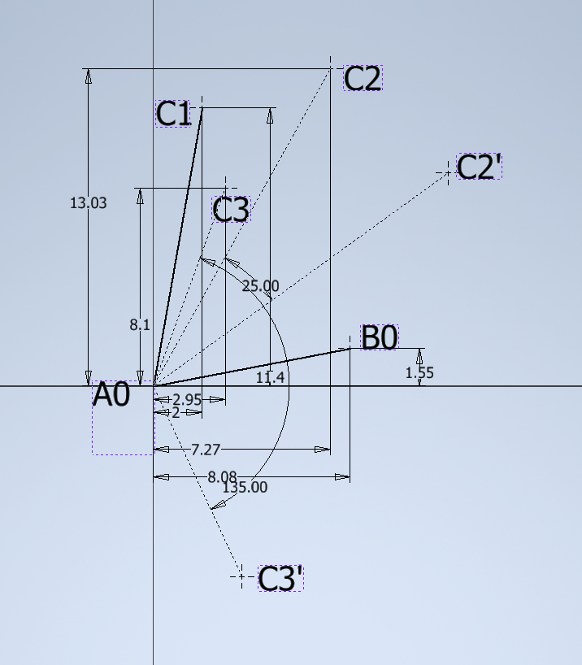

Locate C points, and rotate them with respective angels.

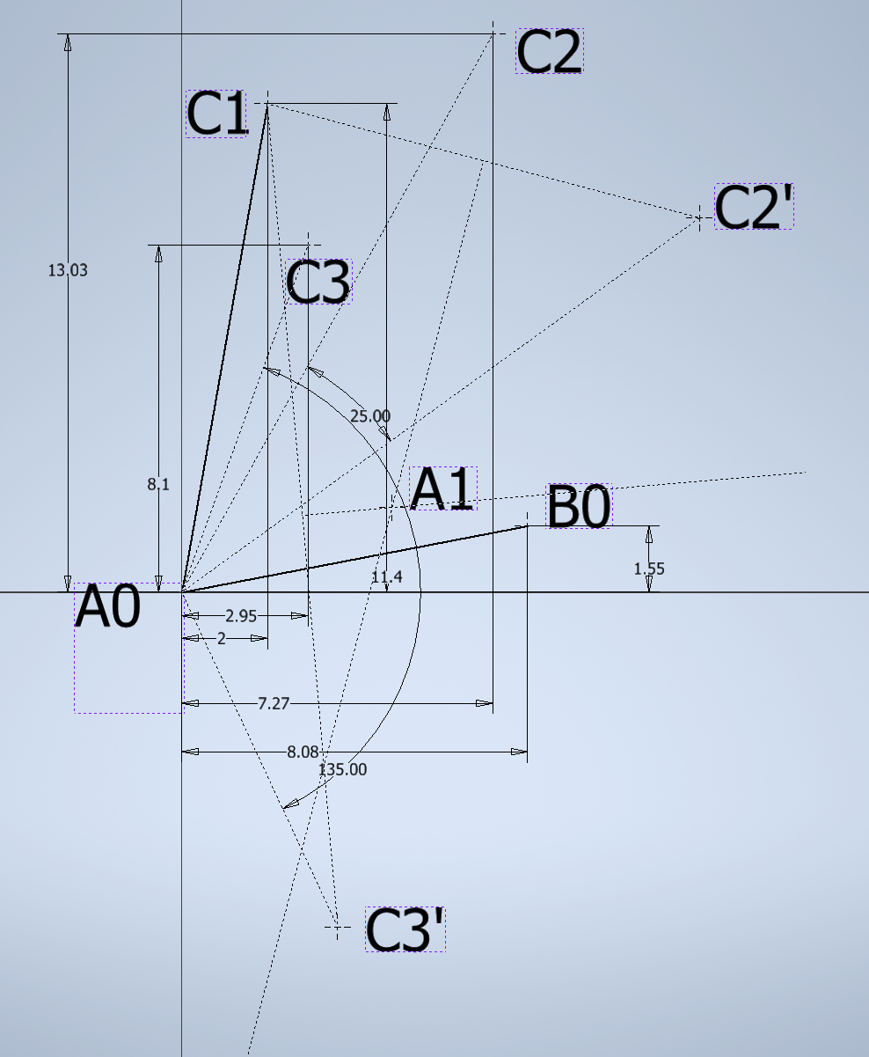

Do the perpendicular bisectors to find A1.

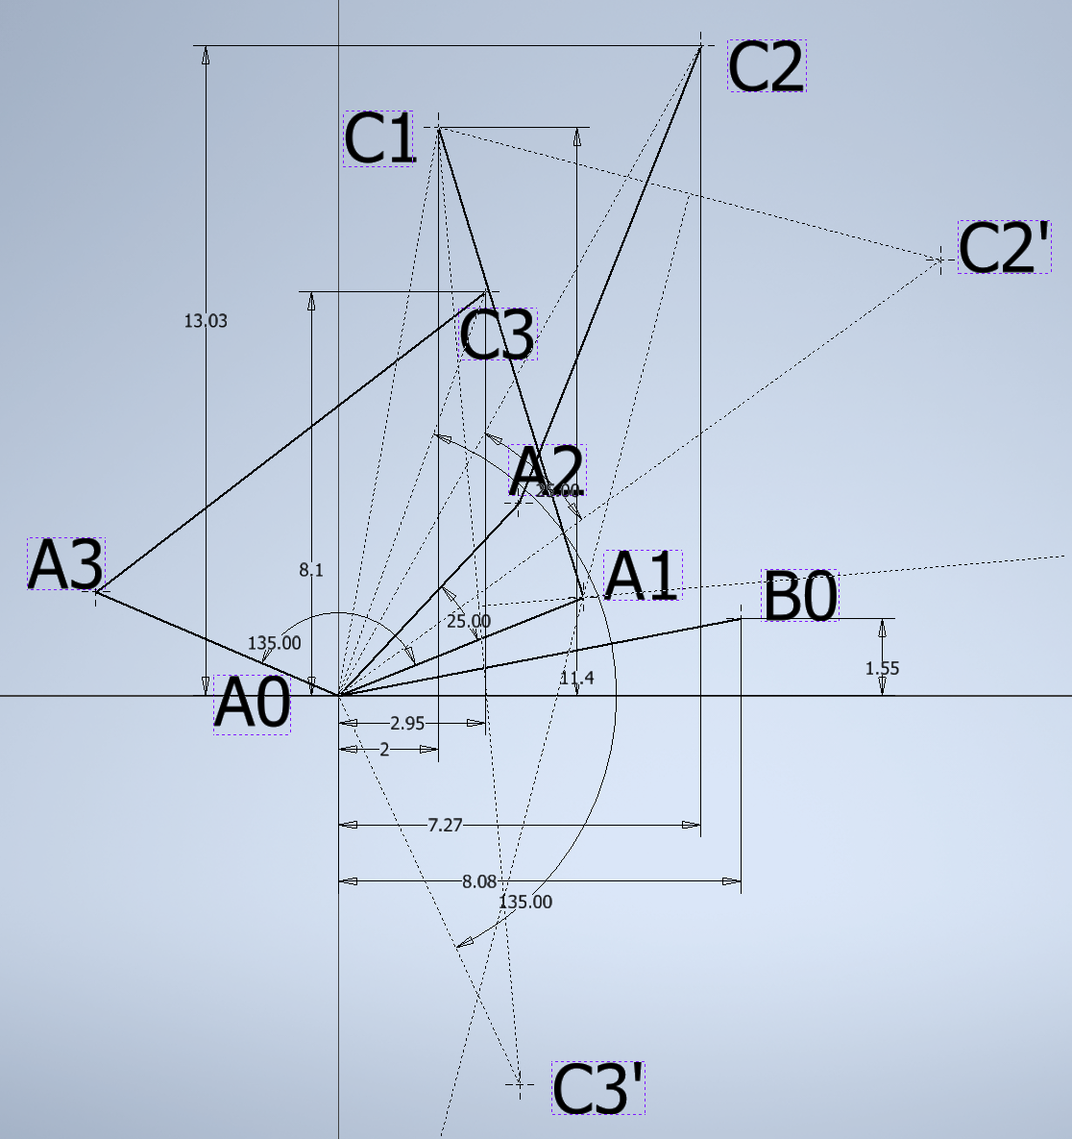

Find the linkage position at 1, 2 and 3.

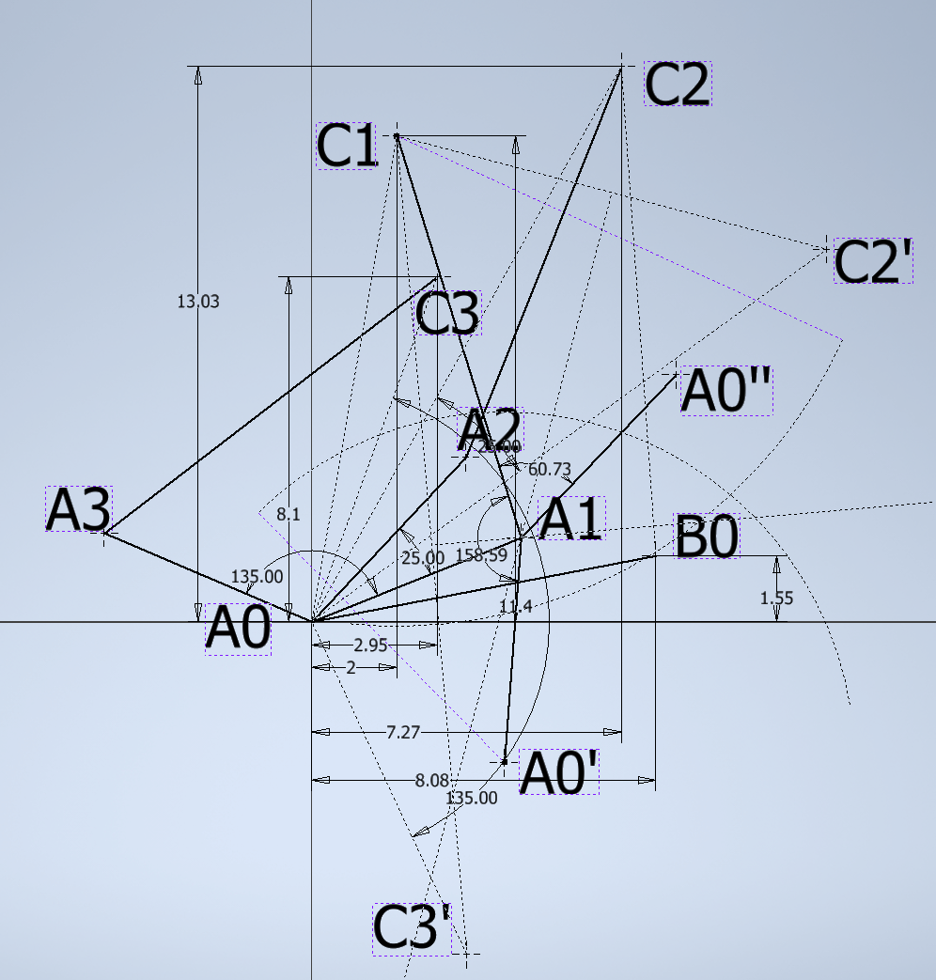

Rotate A0 to the specific angle to make A0’ and A0’’.

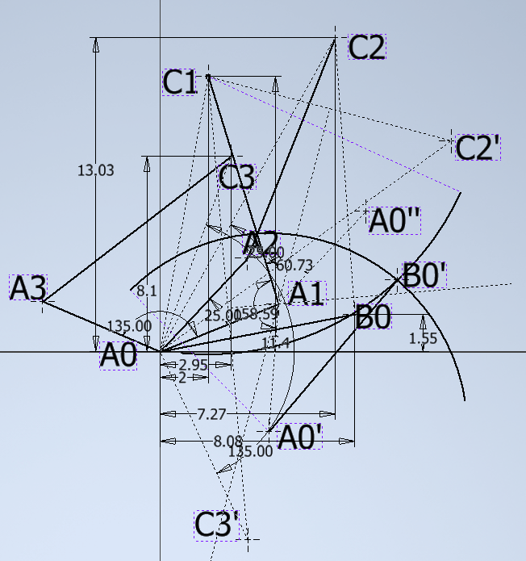

Draw an arc about A0’ with radius A0B0, and draw an arc about C1 with radius C2B0. Find B0’.

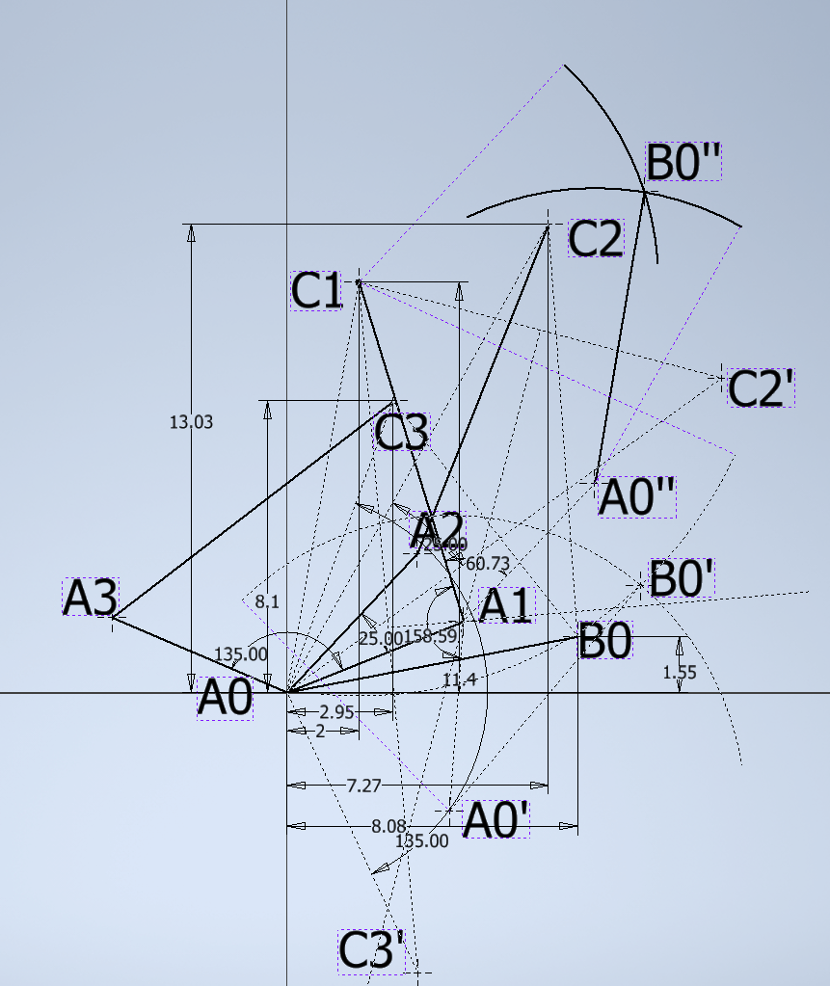

Draw an arc about A0’’ with radius A0B0, and draw an arc about C1 with radius C3B0. Find B0’’.

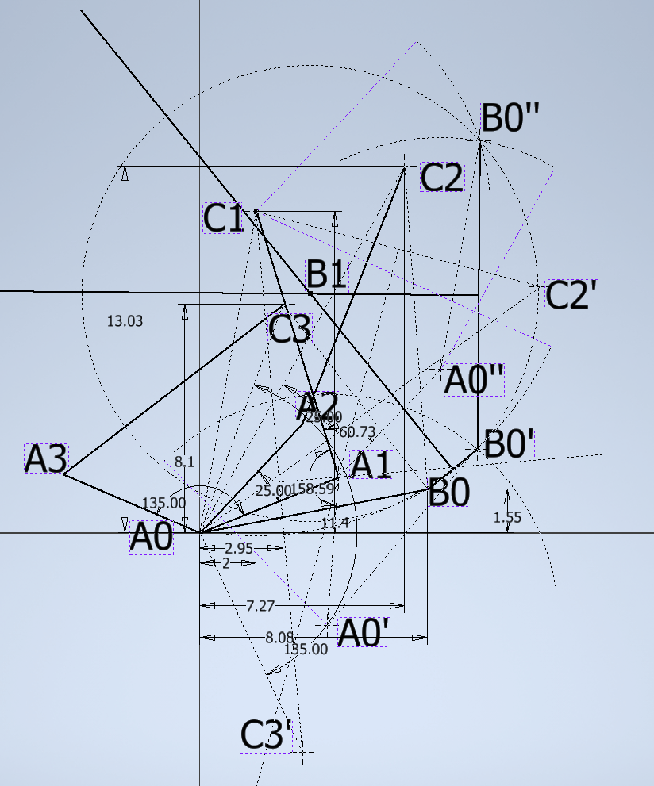

Make B1 with the perpendicular bisectors of B0B0’ and B0’B0’’ .

Result:

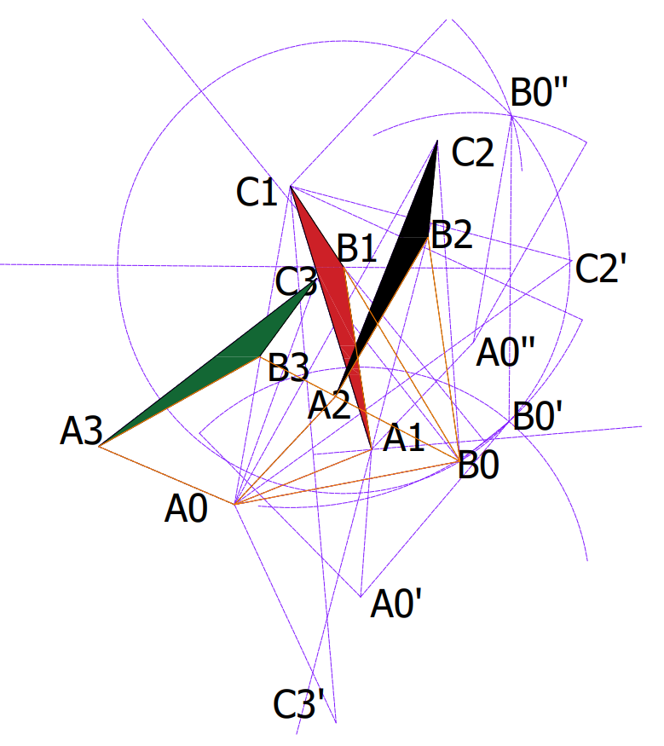

3.

3-a.

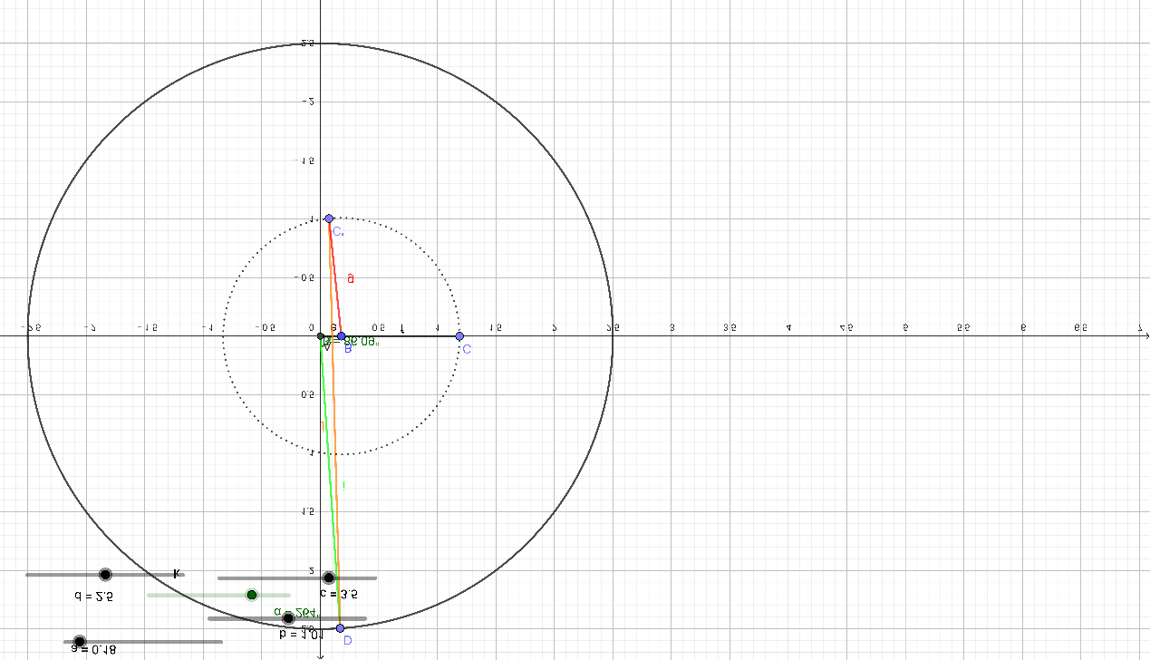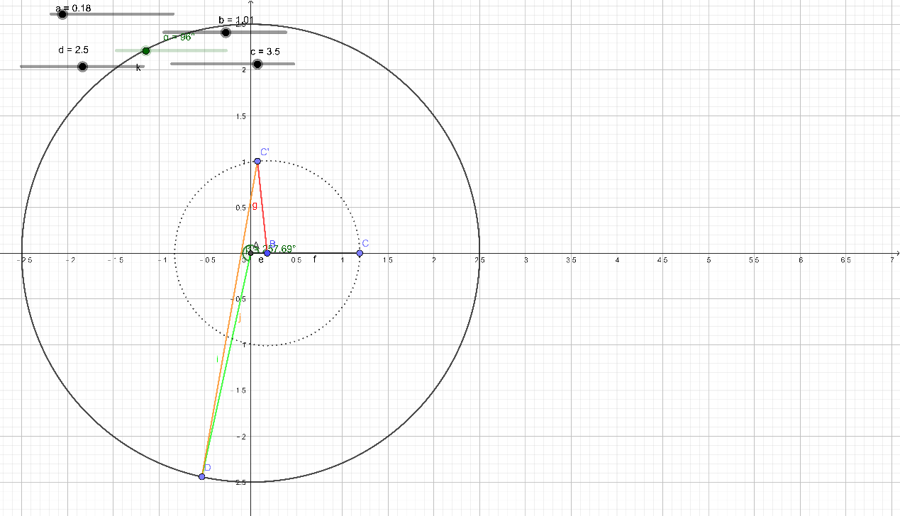

3-b.

This linkage have Circuit Defect as the picture show.